Cascade Shooting Facilities

Ravensdale, Washington
Affiliated with the
National Rifle Association and Civilian Marksmanship Program

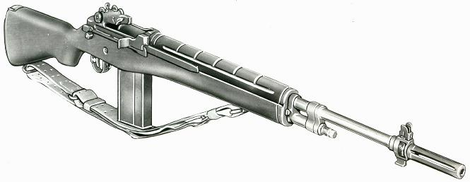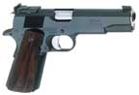

2019 January, Service Pistol-Service Rifle

Name | Pistol |  | Rifle |  | Aggregate
John Benjamin | 485-5x |  | 573-8x |  | 1058-13x
Jerry Bentler | 480-10x |  |  |  | 480-10x
James Croisier | 505-15x | 1st | 568-13x |  | 1073-28x | 2nd
Dave Gere | 496-5x |  | 571-14x |  | 1067-19x
Brian Keelean | 498-1x | 2nd | 57813x | 3rd | 1076-14x | MW
Omayra Linse |  |  | 576-20x |  | 576-20x
Zevin Linse |  |  | 590-27x | 1st | 590-27
George Lopuch | 442-4x |  | 558-10x |  | 1000-14x
Jim Obermeyer | 496-4x |  | 572-24x |  | 1068-28x | 3rd
Kris Schwartz |  |  | 583-26x | 2nd | 583-26x
Mike Schwartz |  |  | 577-22x |  | 577-22x
Dick West |  |  | 543-14x |  | 543-14x
Asa Yam | 335-3x

