Cascade Shooting Facilities

Ravensdale, Washington
Affiliated with the
National Rifle Association and Civilian Marksmanship Program

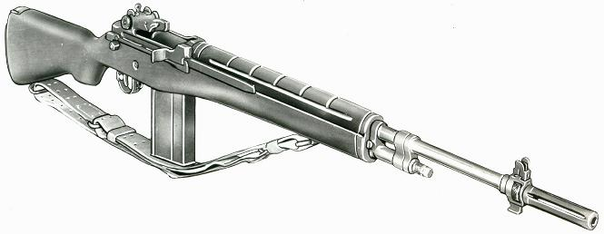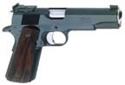

2019 October, Service Pistol-Service Rifle

Name | Pistol |  | Rifle |  | Aggregate
Jerry Bentler | 506-5x |  | 569-10x | 3rd | 1075-15x | 2nd
James Croisier | 532-12x | 1st | 535-6x |  | 1067-18x
Dick Elliott | 266-1x |  | 573-21x | 1st | 839-22x
Cam Fox | 304 |  | 437-2x |  | 741-2x
Dave Gere | 465-4x |  | 568-19x |  | 1033-23x
Bill Hazlett | 399 |  | 550-12x |  | 949-12x
Brian Keelean | 525-3x | 2nd | 570-15x | 2nd | 1095-18x | MW
George Lopuch | 497-7x |  | 543-7x |  | 1040-14x
Jim Obermeyer | 507-5x | 3rd | 567-18x |  | 1074-23x | 3rd
Kort Schwarzmiller | 366 |  | 538-11x |  | 904-11x
Bob Tykulsker | 443-2x |  | 545-4x |  | 988-6x
Asa Yam | 326-1x |  |  |  | 326-1x

