Cascade Shooting Facilities
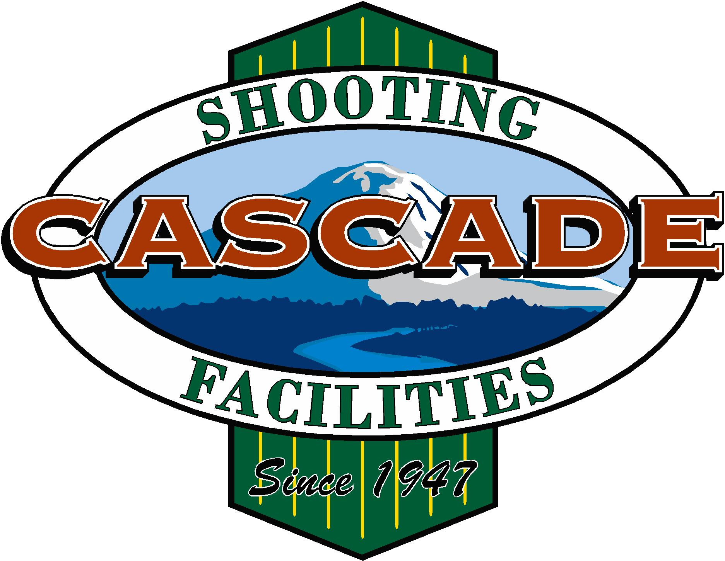
Ravensdale, Washington
Affiliated with the
National Rifle Association and Civilian Marksmanship Program

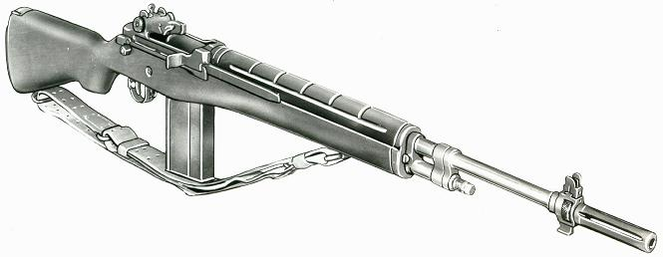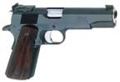

2019 November, Service Pistol-Service Rifle

Name | Pistol |  | Rifle |  | Aggregate
Jerry Bentler | 515-5x |  |  |  | 515-5x
John Baczuk | 458-10x |  | 542-11x |  | 1000-21x
James Croisier | 547-11x | 1st | 528-8x |  | 1075-19x | 4th
Pat Ernsberger | 316 |  | 364-2x |  | 680-2x
Cam Fox | 309 |  | 418 |  | 727
Dave Gere | 461-4x |  | 574-14x | 4th | 1035-18x
Duane Hatch | 509-8x |  | 564-17x |  | 1073-25x | 5th
Bill Hazlett | 393-1x |  | 564-12x |  | 957-13x
Brian Keelean | 504-7x | 5th | 572-3x |  | 1076-10x | 3rd
Zevin Linse |  |  | 596-27x | 1st | 596-27x
George Lopuch | 408 |  | 544-7x |  | 952-7x
Jon McPeak | 333-1x |  | 583-18x | 3rd | 916-19x
Jim Obermeyer | 528-12x | 3rd | 563-12x |  | 1091-24x | 2nd
Brent Olsen | 280 |  | 573-15x | 5th | 853-15x
Jeff Richardson | 390-12x |  | 586-19x | 2nd | 976-21x
Kort Schwarzmiller | 344-12x |  | 509-3x |  | 853-5x
Bob Tykulsker | 404-2x |  | 542-5x |  | 946-7x
Dick West |  |  | 526-11 |  | 526-11x
John Waldenmaier | 278 |  | 521-5x |  | 799-5x
Asa Yam | 416-5x |  |  |  | 416-5x
John Zwosta | 542-10x | 2nd | 572-15x |  | 1114-25x | MW

