Cascade Shooting Facilities
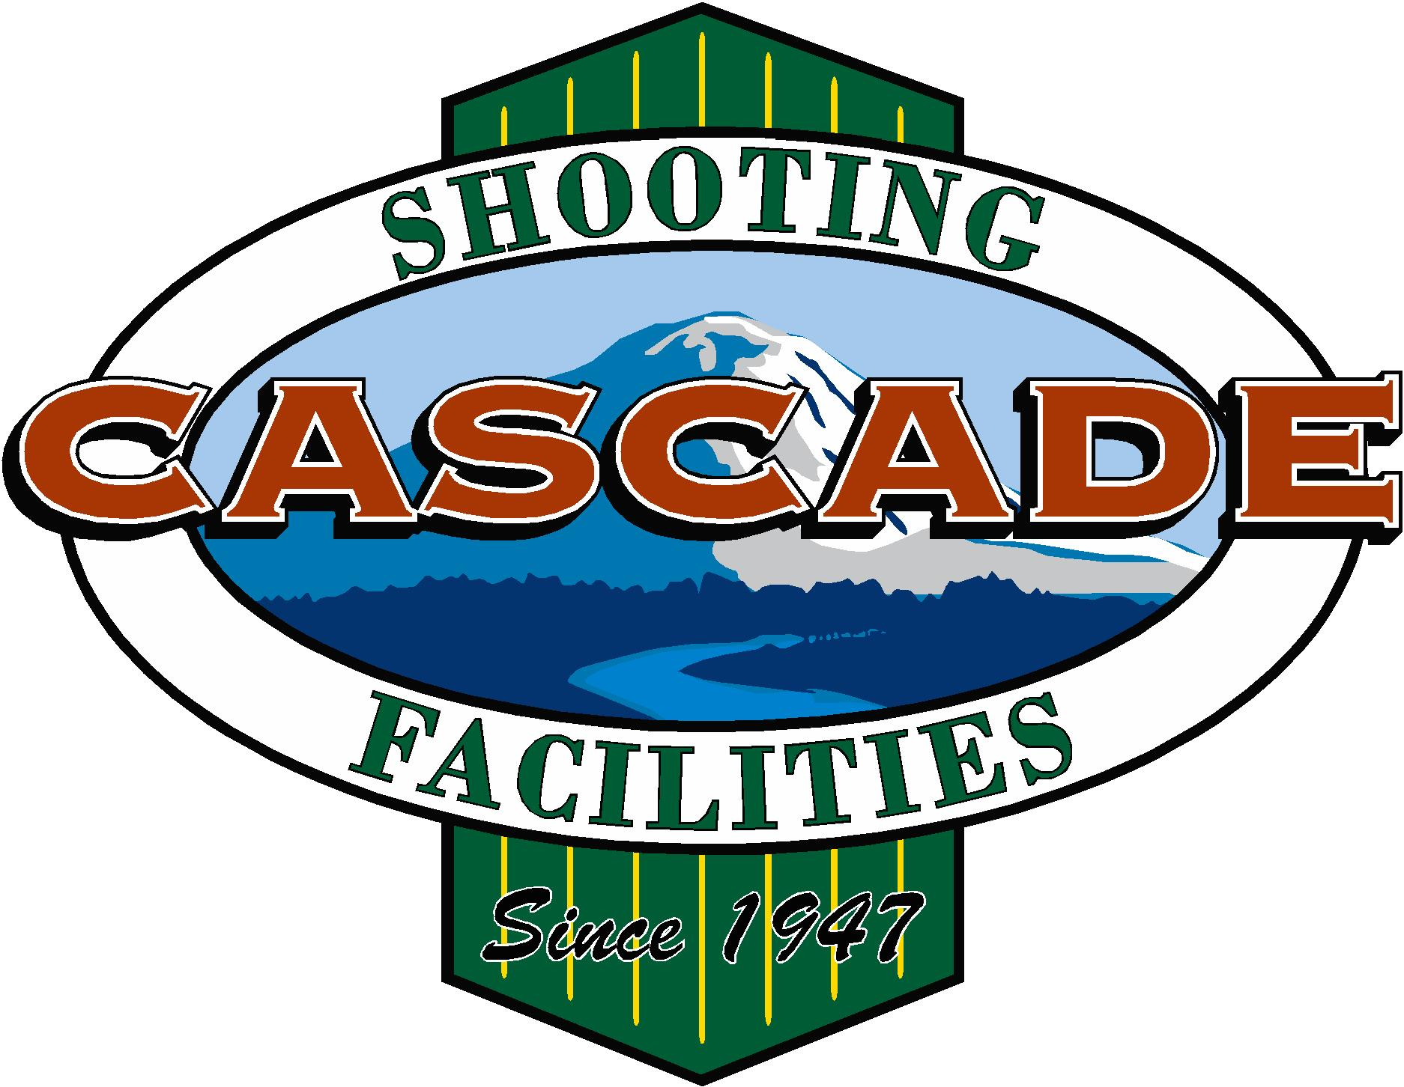
Ravensdale, Washington
Affiliated with the
National Rifle Association and Civilian Marksmanship Program

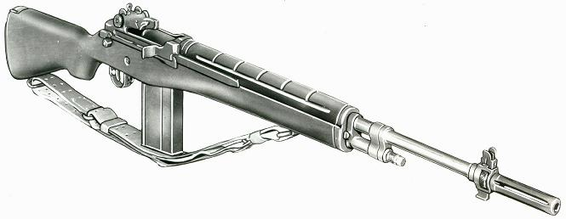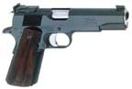

2020 January, Service Pistol-Service Rifle

Name | Pistol |  | Rifle |  | Aggregate
John Baczuk | 513-14x | 1st | 483.8x |  | 996-22x
Jerry Bentler | 477-2x |  | 568-18x |  | 1035-18x
Dick Elliott | 268 |  | 570-13x | 2nd | 838-13x
Dave Gere | 496-11x |  | 574-19x | 1st | 1070-30x | MW
Bill Hazlett | 407 |  | 528-8x |  | 935-8x
Brian Keelean | 504-4x | 2nd | 559-9x |  | 1063-13x | 2nd
George Lopuch | 443-3x |  | 561-7x |  | 1004-10x
Mike Schwartz | 298-1x |  | 547-7x |  | 845-8x
Asa Yam | 441-3x |  |  |  | 441-3x

Our next matches will be a NRA Approved 60 prone at 600 yards on Feb. 15, and the SFC Randy Shughart M14 match on Feb. 16.

