Cascade Shooting Facilities
Ravensdale, Washington
Affiliated with the
National Rifle Association and Civilian Marksmanship Program

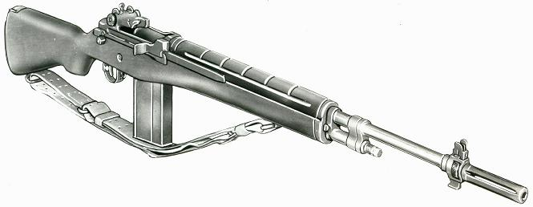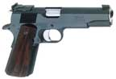

2020 December, Service Pistol-Service Rifle

Name | Pistol |  | Rifle |  | Aggregate
John Benjamin | 456 |  | 571-19x |  | 1027-19x | 2nd
James Croiser | 531-15x | 2nd | 483-1x |  | 1014-16x
Brian Keelean | 440-3x |  | 580-19x | 1st | 1020-22x
George Lopuch | 382-3x |  | 559-13x |  | 941-16x
Connor Matt |  |  | 528-1x |  | 528-1x
Colin Moy | 297 |  |  |  | 297
Jami Obermeyer | 296-2x |  |  |  | 296-2x
Jim Obermeyer | 546-14x | 1st | 572-12x | 2nd | 1118-23x | MW
Mike Schwartz | 309 |  | 558-13x |  | 867-13x
George Smith |  |  | 542-4x |  | 542-4x
Asa Yam | 390-2x |  |  |  | 390-2x

