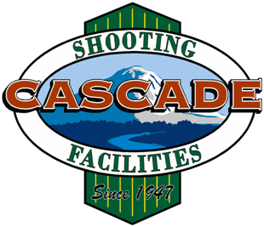 |  |  | Cascade Shooting Facilities Ravensdale, WA Affiliated with  National Rifle Association  and the  Civilian Marksmanship Program
July 13th, 2025
NRA Approved 300yd Championship
Robin Hood Trophy Match
PNW Trophy Match

Name | Category | Class | 1st | x | 2nd | x | 3rd | x | 4th | x | Aggregate | x | Place Awards
Michael Clark | Match | HM | 200 | 8 | 200 | 9 | 198 | 9 | 199 | 12 | 797 | 38 | Match Winner
Gary Rasmussen | Match | HM | 200 | 11 | 198 | 11 | 197 | 12 | 200 | 11 | 795 | 45
Stephen Isaacs | Match | HM | 198 | 6 | 179 | 9 | 197 | 10 | 198 | 6 | 772 | 21
Dave Baalman | Service | MA | 195 | 6 | 192 | 6 | 195 | 8 | 199 | 6 | 781 | 26 | 1st Comb/  High Service
George Lopuch | Match | EX | 184 | 7 | 189 | 3 | 182 | 2 | 179 | 3 | 734 | 15
Randy Bostrom | Match | MK | 169 | 1 | 180 | 3 | 178 | 3 | 154 | 0 | 681 | 7
Rick Bostrom | Service | MK | 168 | 3 | 163 | 1 | 158 | 4 | DNF | 0 | 489 | 8
Lyle Muller | FTR | MK | 195 | 9 | 198 | 11 | 195 | 8 | 195 | 9 | 783 | 37 | F-Class Winner
Steve Singleton | FTR | HM | 197 | 11 | 188 | 2 | 192 | 5 | 195 | 6 | 772 | 24
Tony Kastella | FTR | EX | 186 | 4 | 191 | 1 | 194 | 6 | 192 | 6 | 763 | 17
Wayne Dale | FO | MU | 192 | 5 | 189 | 1 | 186 | 3 | 195 | 6 | 762 | 15

